
CSA15 – CLOUD COMPUTING AND BIG DATA ANALYTICS

ASSIGNMENT 1 – CO1
Design, Analyse and Validate a Cloud-Based Solution for Migrating a Legacy University Management System
CO1: Apply cloud computing technologies including hardware–software evolution, virtualization, web services, and service models to develop cloud-based solutions.

Field | Details | Field | Details
Student Name | Vijay A | Register Number | 192511030
Department / Section | B.E(CSE) | Academic Year / Semester
Faculty Name | Dr.R.Latha | Nature of Assignment | Individual
Duration | 1 Week | Total Marks | 50
Submission Date |  | Evaluation Date

MARK SHEET (Rubric-based evaluation)
Task | Title | Max | Awarded | Evidence / evaluation focus
1 | Introduce Cloud Computing | 3 |  | Definition; characteristics; deployment models; scenario mapping
2 | Trace Evolution and Hardware Evolution | 3 |  | Timeline; hardware evolution; relevance to university
3 | Analyse Internet Software Evolution | 3 |  | Web/software evolution; SOA; APIs; scenario relevance
4 | Apply Server Virtualization | 5 |  | Hypervisor types; VM/container comparison; consolidation; limitations
5 | Apply Web Services | 4 |  | SOA and SOAP/REST; three university APIs; request/response examples
6 | Analyse IaaS, PaaS and SaaS | 5 |  | Responsibility layers; five-application mapping; comparison; providers
7 | Examine XaaS | 3 |  | Four or more variants; two justified choices; provider risks
8 | Design Cloud Solution Architecture | 5 |  | Labelled diagram; deployment/service models; scaling; security; DR
9 | Hands-on Implementation and Documentation | 4 |  | Running VM/container; PaaS/SaaS; tests; actual screenshots
10 | Evaluate and Recommend Final Solution | 7 |  | Three-way comparison; 3-year costs; risks; phased roadmap
11 | Day-4 Design Challenge | 8 |  | Impact; evaluation; adaptation; evidence-based defence
 | TOTAL | 50 |  | Percentage :

EVIDENCE VERIFICATION CHECKLIST

Tasks | Evidence expected | Status (✓ / P / ✗) | Evaluator note
1–3 | Conceptual explanations, comparisons and relevant illustrations | ✓ | Explanations and relevant scenario mapping documented
4 | Virtualization calculations with stated assumptions and peak-load caution | ✓ | Calculations present; practical capacity validation recommended
5–7 | API examples, service responsibility table and justified XaaS choices | ✓ | Required conceptual evidence documented
8 | Labelled architecture diagram, caption below figure and component justification | ✓ | Architecture documented; sizing assumptions need testing
9 | Actual code, environment details, execution logs, API outputs and screenshots | P | Procedures provided; actual execution evidence not established
10 | Cost assumptions, 3-year totals, risk controls and migration roadmap | ✓ | Estimates and rationale documented
11 | Day-4 changes, 10× load strategy, 99.9% target and 40-college isolation | ✓ | Design analysis documented; practical validation pending

IMPLEMENTATION EVIDENCE CHAIN

Evidence item | Status | Observation
Source code | ✓ | Flask REST API and Dockerfile provided in the proposed implementation
Virtualization | P | Docker container configuration documented; running-container evidence required
PaaS or SaaS | P | Managed web-service deployment procedure described; live deployment not verified
Functional test | P | Expected HTTP 200 response and JSON output documented; actual output required
Failure case | P | HTTP 404 test case documented; actual execution record required
Screenshots | P | Screenshot requirements identified; authentic screenshots need verification
Reproducibility | ✓ | Build commands, run commands, endpoints and expected results specified

OVERALL REMARKS

_______________  Student Signature | _______________  Faculty Signature | _______________  Program Director
MANDATORY SUBMISSION EVIDENCE CHECK
✓ = Present in documented answer; P = Partly present; ✗ = Missing / not satisfied
Task | Evidence expected | Status | Evaluator note
1 | Cloud definition, characteristics, deployment models and scenario mapping | ✓ | All conceptual requirements covered
2 | Evolution timeline, hardware development and university relevance | ✓ | Well explained with relevant examples
3 | Internet software evolution, SOA and APIs | ✓ | Clear explanation and scenario relevance
4 | Hypervisors, VM/container comparison and consolidation calculations | ✓ | Calculations included; peak-load limitations discussed
5 | SOAP/REST comparison and three university APIs | ✓ | API methods and request/response examples documented
6 | IaaS/PaaS/SaaS responsibility layers and application mapping | ✓ | All five applications categorized with justification
7 | XaaS variants and two justified selections | ✓ | Six variants explained; DBaaS and DRaaS recommended
8 | Labelled architecture, scaling, security and disaster recovery | ✓ | Design and component justifications documented
9 | Working container, PaaS/SaaS deployment, actual tests and screenshots | P | Code and procedures provided; actual execution evidence requires verification
10 | Three-year cost comparison, risks and migration roadmap | ✓ | Cost assumptions, calculations and recommendations included
11 | Impact analysis, 10× load, 99.9% availability and tenant isolation | ✓ | Changed requirements evaluated; load-test evidence recommended

IMPLEMENTATION EVIDENCE CHAIN
Evidence item | Status | Observation
Source code | ✓ | Python Flask REST API and Dockerfile documented
Virtualization | P | Docker build and run procedures provided; execution screenshot required
PaaS or SaaS | P | Cloud deployment steps described; actual deployment confirmation required
Functional test | P | HTTP 200 and expected JSON response documented; actual test output required
Failure case | P | HTTP 404 test case included; execution evidence required
Screenshots | P | Required screenshots identified but authenticity and completeness not verified
Reproducibility | ✓ | Installation, configuration, commands and testing steps documented
Interpretation | ✓ | Technical outcomes and implementation limitations explained
Code and report consistency | ✓ | Proposed API, Docker configuration and testing procedure are aligned

SUBMISSION CHECKLIST (Not Separately Marked)
Requirement | Status
All 11 tasks answered | ☒ Yes ☐ Partly ☐ No
Cloud concepts and comparisons explained | ☒ Yes ☐ Partly ☐ No
Virtualization calculations included | ☒ Yes ☐ Partly ☐ No
API examples and service models explained | ☒ Yes ☐ Partly ☐ No
Cloud architecture diagram included | ☒ Yes ☐ Partly ☐ No
Implementation and testing evidence provided | ☐ Yes ☒ Partly ☐ No
Three-year cost analysis and roadmap included | ☒ Yes ☐ Partly ☐ No
Day-4 design challenge completed | ☒ Yes ☐ Partly ☐ No
Figures and screenshots included | ☐ Yes ☒ Partly ☐ No
Table and figure numbering correct | ☐ Yes ☒ Partly ☐ No
Viva recommended | ☒ Yes ☐ No

CSA15 – Cloud Computing and Big Data Analytics
ASSIGNMENT 1
CO1: Apply cloud computing technologies including hardware–software evolution, virtualization, web services, and service models to develop cloud-based solutions.

Assignment Title: Design, Analyse and Validate a Cloud-Based Solution for Migrating a Legacy University Management System (Total Marks – 50)
Duration: 1 week
Scenario – Smart Campus Cloud Migration
A multi-campus university currently runs its Student Information System, Learning Management System, Library System, Exam Portal and Email on ageing physical servers in a single on-premise data centre. Each application has its own dedicated server, which stays idle for most of the year but fails to cope during admissions, result publication and online-exam weeks.
The university's current environment is:
- 12 physical servers, average CPU utilisation of about 15%, with peaks above 95% during admissions and exams
- Approximately 25,000 students and 2,000 staff across 4 campuses
- Applications built as large monolithic programs, with no public interfaces for mobile apps or partner colleges
- High capital expenditure, slow procurement (6–8 weeks per server) and no disaster recovery site
As a cloud consultant, you must study how computing evolved to the cloud model, and then design a cloud-based solution that uses virtualization, web services and an appropriate mix of service models (IaaS, PaaS, SaaS and XaaS) for the university. All recommendations must be justified in terms of cost, scalability, availability and manageability.
Design Challenge:
On Day 4, the university announces that it will launch a mobile app and open student-record and fee-payment services to 40 affiliated colleges. Expected load is 10 times the current peak, with a requirement of 99.9% availability and a limited operating budget. Re-evaluate your original design and decide whether it should be retained, modified or redesigned.
TASK 1 – Introduce Cloud Computing and Map It to the Scenario (3 Marks)
Design and Propose cloud computing model for the context of the university's problems.
- Definition of cloud computing and the five essential characteristics (on-demand self-service, broad network access, resource pooling, rapid elasticity, measured service)
- Deployment models (public, private, hybrid, community) and which one suits the university
- Three problems of the current on-premise setup and how each cloud characteristic addresses them
- Benefits and limitations of cloud adoption for the university
Evidence Expected
A clear explanation of cloud characteristics and deployment models, mapped to the university's actual problems.
TASK 2 – Trace the Evolution and Hardware Evolution (3 Marks)
Trace how computing infrastructure evolved to make cloud computing possible.
- A timeline from mainframes, minicomputers and PCs, to client–server, clusters, grid computing, utility computing and cloud
- Hardware evolution: multi-core processors, commodity servers, high-capacity storage, high-speed networking and data centres
- How each stage solved a limitation of the previous one
- Which stage the university's current system corresponds to, with reasons
Evidence Expected
A labelled timeline or diagram, with a justified explanation of how hardware advances enabled the cloud.
TASK 3 – Analyse Internet Software Evolution (3 Marks)
Explain how internet software evolved and why it supports cloud services.
- Evolution from static web pages to dynamic web, Web 2.0, SOA, mashups and cloud-hosted applications
- Role of browsers, HTTP, AJAX and APIs in delivering software over the internet
- Comparison between desktop software, client–server software and web-delivered software
- How this evolution affects the design of the university's applications
Evidence Expected
A comparative explanation of software evolution stages, linked to the university's application design.
TASK 4 – Apply Server Virtualization (5 Marks)
Apply server virtualization to consolidate the university's 12 physical servers.
- Explain how a hypervisor works, and distinguish Type-1 and Type-2 hypervisors, with examples
- Compare full virtualization, para-virtualization, OS-level virtualization (containers) and hardware-assisted virtualization
- Propose which applications should run as virtual machines and which as containers, with reasons
- Calculate the consolidation: with an average utilisation of 15% per server and a target host utilisation of 70%, estimate how many physical hosts are needed (show your assumptions and working)
- Discuss live migration, snapshots and resource over-commitment as benefits, and the risks of virtualization (noisy neighbour, hypervisor failure, security isolation)
Show your calculation. A final number without working will not receive full credit.
Evidence Expected
A justified virtualization plan with a worked consolidation calculation and discussion of benefits and risks.
TASK 5 – Apply Web Services (4 Marks)
Analyse web services to expose the university's functions to other systems.
- Overview of web services and their role in cloud and SOA
- Compare SOAP, WSDL, UDDI and RESTful services (HTTP methods, JSON/XML)
- Identify at least three university functions to expose as web services (for example, result lookup, fee payment, library search) and define the endpoint, method and sample request/response for each
- Justify whether SOAP or REST is more suitable for each function
Evidence Expected
A defined set of web services with sample request/response formats and a justified choice of SOAP or REST
TASK 6 – Analyse the Service Models: IaaS, PaaS and SaaS (5 Marks)
Analyse which service model fits each university application.
- Define IaaS, PaaS and SaaS, and show who manages which layer (hardware to application) in each model
- Categorise the five university applications (SIS, LMS, Library, Exam Portal, Email) into IaaS, PaaS or SaaS, with reasons
- Compare the models on control, cost, scalability, maintenance effort and vendor lock-in
- Give one real provider example for each model
Present your categorisation in a table, but explain the reasoning behind each decision. A table alone is not sufficient.
Evidence Expected
A reasoned mapping of applications to service models, supported by a layer-wise responsibility comparison.
TASK 7 – Examine XaaS (3 Marks)
Examine the broader XaaS (Anything-as-a-Service) concept for the university.
- Explain XaaS and describe at least four variants (for example DaaS, BaaS/MBaaS, FaaS, DBaaS, Security-as-a-Service, Disaster-Recovery-as-a-Service)
- Select two XaaS offerings that would benefit the university, and justify them
- Discuss the risks of over-reliance on multiple 'as-a-Service' providers
Evidence Expected
An analysis of XaaS variants, with justified selection of two offerings for the university.
TASK 8 – Design the Cloud Solution Architecture (5 Marks)
Bloom's Level: Level 6 – Create | Action verbs: Design, Construct, Propose
Create a complete cloud architecture for the university by combining virtualization, web services and service models.
- An architecture diagram showing users, load balancer, web/application tier, database tier, storage, API layer and DR region
- The deployment model and the service model chosen for each component
- How elasticity (auto-scaling) will handle admissions and exam peaks
- Basic security and availability measures (access control, encryption, backup, multi-zone deployment)
Evidence Expected
A labelled architecture diagram with written justification for each component and design decision.
TASK 9 – Hands-on Implementation and Documentation (4 Marks)
Implement a small proof-of-concept of your design using a free-tier cloud account or a local virtualization tool.
- Create a virtual machine or container (using AWS/Azure/GCP free tier, VirtualBox, or Docker) and host a simple web page or REST API for one university function
- Deploy a SaaS or PaaS component (for example a cloud-hosted database, a serverless function or a static site)
- Test the web service with a client (browser, Postman or curl) and record the output
- Provide screenshots, configuration steps and any issues faced
Evidence Expected
Annotated screenshots and clear, reproducible steps showing that the proof-of-concept works.
TASK 10 – Evaluate and Recommend the Final Solution (7 Marks)
Evaluate your design and recommend the final cloud solution for the university.
- Compare on-premise, IaaS-based and PaaS/SaaS-based options on cost (CapEx vs OpEx), scalability, availability, security and effort
- Estimate a simple 3-year cost comparison using stated assumptions
- Identify the main risks (vendor lock-in, data privacy, downtime, skills gap) and give mitigation steps
- Provide your final recommendation and a short migration roadmap (which application moves first, and why)
Your recommendation must be supported by the analysis in the previous tasks. Choosing a popular cloud provider without justification is not sufficient.
Evidence Expected
A technically justified recommendation, supported by a cost comparison, risk analysis and migration roadmap.
DAY-4 DESIGN CHALLENGE
TASK 11 – Re-evaluate and Adapt the Design (8 Marks)
Changed Requirement
The university will now launch a mobile app and open student-record and fee-payment services to 40 affiliated colleges. Expected load is 10 times the current peak, availability must be 99.9%, and the operating budget is limited.
Re-evaluate your original design in response to these changed conditions. You may:
RETAIN → MODIFY → or REDESIGN
your original solution.
Impact Analysis – 2 Marks
Discuss:
- What has changed from the original problem
- Which original assumptions (load, users, availability, cost) are affected
- Why the web services and APIs now become critical
- How multi-tenant access by 40 colleges affects security and isolation
Evidence Expected: A clear analysis of how the changed requirements affect the original cloud design.
Evaluation of the Original Design – 2 Marks
Discuss:
- Whether the chosen service models and virtualization plan can handle a 10x load
- Whether auto-scaling and the single-region deployment are sufficient for 99.9% availability (about 8.76 hours of downtime allowed per year)
- Whether cost remains acceptable under the new load
- Whether another service model or XaaS offering would give better overall results
Evidence Expected: A technically supported evaluation of the original design under the new conditions.
Adaptation or Redesign – 2 Marks
Discuss:
- Decide whether to retain, modify or redesign the solution
- Describe the revised architecture (for example API gateway, container orchestration, serverless components, multi-zone deployment or a hybrid model)
- Explain what changed in the service model mix and in the virtualization approach
- If you retain the original design, give sufficient technical justification for why no change is required
Evidence Expected: An appropriate design response to the changed requirement, with clear technical reasoning.
Evidence-Based Defence – 2 Marks
Discuss:
- Capacity and availability calculations
- Cost comparison between the original and the revised design
- Security and multi-tenancy considerations
- Trade-offs such as vendor lock-in, complexity and migration effort
Evidence Expected: A well-supported final decision that follows logically from the analysis.
MARK DISTRIBUTION
Task | Title | Bloom's Level | Marks
Task 1 | Cloud Computing – Introduction & Characteristics | L2 – Understand | 3
Task 2 | Evolution & Hardware Evolution | L2 – Understand | 3
Task 3 | Internet Software Evolution | L2 – Understand | 3
Task 4 | Server Virtualization | L3 – Apply | 5
Task 5 | Web Services | L3 – Apply | 4
Task 6 | Service Models: IaaS, PaaS, SaaS | L4 – Analyze | 5
Task 7 | XaaS | L4 – Analyze | 3
Task 8 | Design the Cloud Solution Architecture | L6 – Create | 5
Task 9 | Hands-on Implementation & Documentation | L3 – Apply | 4
Task 10 | Evaluate & Recommend the Final Solution | L5 – Evaluate | 7
 | Subtotal

Task 11 | Day-4 Design Challenge | L4 / L5 / L6 | 8
 | TOTAL |  | 50

TASK 1-Introduce Cloud Computing and Map It to the Scenario Answer
Definition of Cloud Computing
Cloud computing is a technology that provides computing services such as servers, storage, databases, networking and software through the internet. It allows users to access resources without maintaining their own physical servers.
For the university, cloud computing helps manage student records, online examinations, library services and learning platforms efficiently.
Five Essential Characteristics of Cloud Computing
- On-Demand Self-Service: The university can access computing resources whenever needed without manual setup.
- Broad Network Access: Students and staff can access university applications from anywhere using the internet.
- Resource Pooling: Computing resources are shared among different university departments and campuses.
- Rapid Elasticity: Server capacity can automatically increase during admissions and online examinations.
- Measured Service: The university pays based on the computing resources it uses.
Cloud Deployment Models
Deployment Model | Description
Public Cloud | Services are provided over the internet by providers such as AWS, Azure and Google Cloud.
Private Cloud | Cloud infrastructure is dedicated to one organization.
Hybrid Cloud | Combines private and public cloud infrastructure.
Community Cloud | Infrastructure is shared by organizations with similar requirements.
Recommended Model: Hybrid Cloud
A hybrid cloud is suitable for the university because sensitive student records can be maintained in a controlled private environment, while public cloud resources can handle high traffic during admissions and examinations.

Mapping Cloud Computing to University Problems
Existing Problem | Cloud Solution
Physical servers remain underutilized most of the year. | Resource pooling improves server utilization.
Servers become overloaded during examinations and admissions. | Rapid elasticity increases computing capacity during peak periods.
Purchasing new servers takes 6–8 weeks and increases costs. | On-demand self-service enables faster resource provisioning.
Benefits and Limitations
Benefits:
- Reduces the cost of purchasing and maintaining physical servers.
- Improves scalability during peak usage.
- Allows students and staff to access services from anywhere.
- Supports backup, disaster recovery and better availability.
Limitations:
- Requires reliable internet connectivity.
- Student data privacy and security must be maintained.
- Dependence on cloud service providers may create vendor lock-in.
Conclusion
Cloud computing provides a scalable, flexible and cost-effective solution for the university. By adopting a hybrid cloud model, the university can improve application performance, reduce infrastructure costs and provide reliable digital services to students and staff.

TASK 2-Trace the Evolution and Hardware Evolution ANSWER

Introduction
Cloud computing evolved from traditional computing systems to modern internet-based services. Improvements in processors, storage, networking and data centres made cloud computing faster, more reliable and cost-effective.

Evolution of Computing
Stage | Evolution and Improvement
Mainframe Computers (1950s–1960s) | Large centralized computers used by multiple users.
Minicomputers (1960s–1970s) | Smaller and more affordable than mainframes.
Personal Computers (1980s) | Allowed individuals to perform computing tasks independently.
Client–Server Computing (1990s) | Connected multiple computers to centralized servers for sharing resources.
Cluster Computing (1990s) | Connected multiple servers to improve performance and reliability.
Grid Computing (2000s) | Combined computing resources from different locations.
Utility Computing (2000s) | Introduced usage-based payment for computing resources.
Cloud Computing (2000s–Present) | Provides scalable computing resources through the internet.
Evolution Timeline
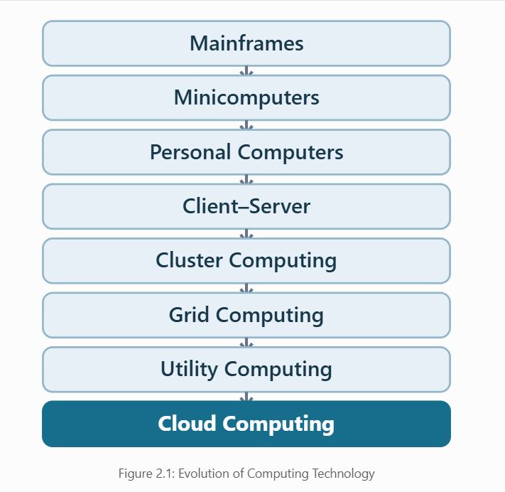
Hardware Evolution Supporting Cloud Computing
- Multi-Core Processors: Enable servers to execute multiple tasks simultaneously.
- Commodity Servers: Affordable servers reduce infrastructure costs.
- High-Capacity Storage: Allows universities to store large amounts of student and academic data.
- High-Speed Networking: Supports faster communication between servers and campuses.
- Modern Data Centres: Provide centralized management, cooling, backup and reliable computing infrastructure.
University Scenario Mapping
The university's existing system mainly follows the traditional client–server model, because it uses 12 dedicated physical servers to manage applications such as student information, examinations, library services and email.
The existing system has low average CPU utilization of 15% and struggles during peak periods.
By migrating to cloud computing, the university can share computing resources, automatically scale applications and improve service availability across its four campuses.
Conclusion
The evolution from mainframes to cloud computing has improved processing power, resource sharing, scalability and cost efficiency. Cloud computing helps the university overcome the limitations of traditional physical servers and deliver better digital services.

TASK 3-Analyse Internet Software Evolution Answer

Introduction
Internet software has evolved from simple static web pages to advanced cloud-based applications. This evolution allows users to access software through web browsers without installing applications on individual computers.
For the university, internet software enables online admissions, student result checking, learning management and fee payments.

Evolution of Internet Software
Stage | Description
Static Web (Web 1.0) | Websites displayed fixed information with limited user interaction.
Dynamic Web | Websites started providing interactive content using databases and server-side programming.
Web 2.0 | Enabled user participation, collaboration and content sharing.
Service-Oriented Architecture (SOA) | Allowed different applications to communicate through reusable services.
Mashups | Combined information and services from multiple applications into one interface.
Cloud-Hosted Applications | Enabled users to access scalable applications directly through the internet.

Internet Software Evolution Diagram
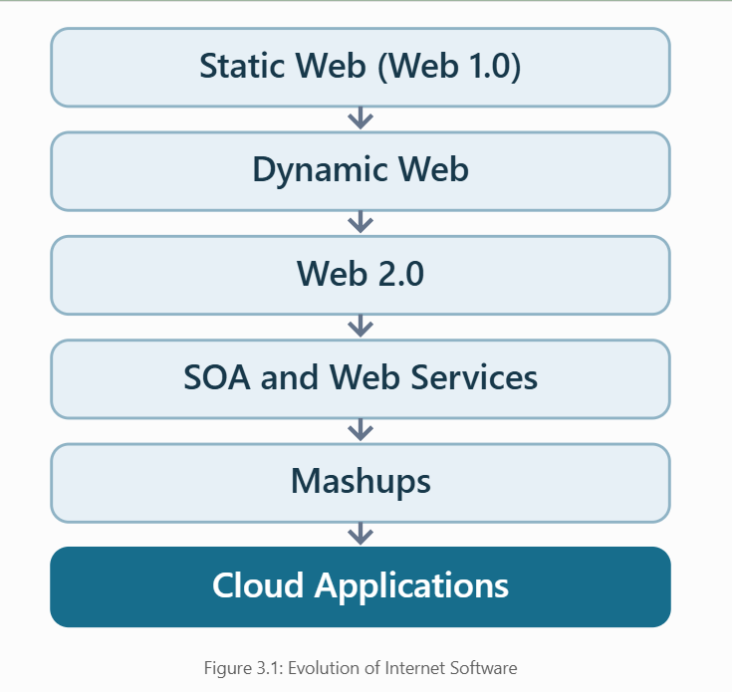
Role of Internet Technologies
- Web Browsers: Allow students and staff to access university applications without installing separate software.
- HTTP/HTTPS: Enable communication between users and university web servers, with HTTPS providing encrypted communication.
- AJAX: Updates web page content without reloading the entire page.
- APIs: Allow applications such as the Student Information System, Exam Portal and mobile apps to exchange information.
Comparison of Software Models
Feature | Desktop Software | Client–Server Software | Web-Based Software
Installation | Required on each computer | Client software may be needed | Mainly requires a browser
Accessibility | Usually local | Connected network | Internet access
Maintenance | Individual updates | Server and client updates | Mostly centralized updates
Scalability | Limited | Depends on server capacity | Can scale using cloud resources
Example | Offline student records | Traditional university ERP | Cloud-based student portal
Application to the University
The university can modernize its existing applications using internet-based software technologies.
- Convert the Student Information System into a web-based application.
- Provide online examination and result-checking services.
- Use REST APIs to connect the university website and mobile applications.
- Integrate library, examination and fee-payment services through reusable APIs.
- Host applications on cloud infrastructure to improve accessibility and scalability.
Conclusion
Internet software evolution has made applications more accessible, interactive and scalable. By adopting web-based applications, SOA and APIs, the university can improve communication between systems, reduce maintenance effort and provide efficient online services to students and staff.
TASK-4 Apply Server Virtualization: Answer

Introduction
Server virtualization is a technology that allows multiple virtual machines (VMs) to run on a single physical server. It improves resource utilization, reduces hardware costs and simplifies server management.
The university currently uses 12 physical servers with an average CPU utilization of 15%. Virtualization can help consolidate these servers and improve efficiency.
Hypervisor and Its Types
A hypervisor is software that creates and manages virtual machines by sharing the physical server's resources.
Type | Description | Examples
Type 1 (Bare-Metal) | Runs directly on physical hardware and provides high performance. | VMware ESXi, Microsoft Hyper-V
Type 2 (Hosted) | Runs on top of an existing operating system. | Oracle VirtualBox, VMware Workstation
Recommended: Type 1 hypervisors are suitable for the university because they provide better performance and centralized management.
Types of Virtualization
Type | Description
Full Virtualization | Runs complete guest operating systems without modifying them.
Para-Virtualization | Uses virtualization-aware guest operating systems or drivers to improve efficiency.
OS-Level Virtualization | Uses containers that share the host OS kernel.
Hardware-Assisted Virtualization | Uses processor features such as Intel VT-x and AMD-V to improve virtualization performance.

Virtual Machines vs Containers
University Application | Recommended Technology | Reason
Student Information System | Virtual Machine | Supports legacy software and its operating system.
Learning Management System | Container | Enables easy scaling and deployment.
Library System | Container | Lightweight and efficient.
Exam Portal | Container | Supports rapid scaling during examinations.
Legacy Database | Virtual Machine | Maintains compatibility with existing software.
Server Consolidation Calculation
Given:
- Number of physical servers = 12
- Average CPU utilization = 15%
- Target host utilization = 70%
Step 1: Calculate total CPU workload
Total CPU Workload = Number of Servers × Average CPU Utilization
= 12 × 15%
= 180%
Step 2: Calculate the number of hosts required
Required Hosts = Total CPU Workload ÷ Target Host Utilization
= 180% ÷ 70%
= 2.57
Rounding up:
Required Hosts = 3 Physical Servers
Result: The university can theoretically consolidate its 12 physical servers into 3 physical hosts, assuming equal server capacities and that CPU is the main limiting resource.

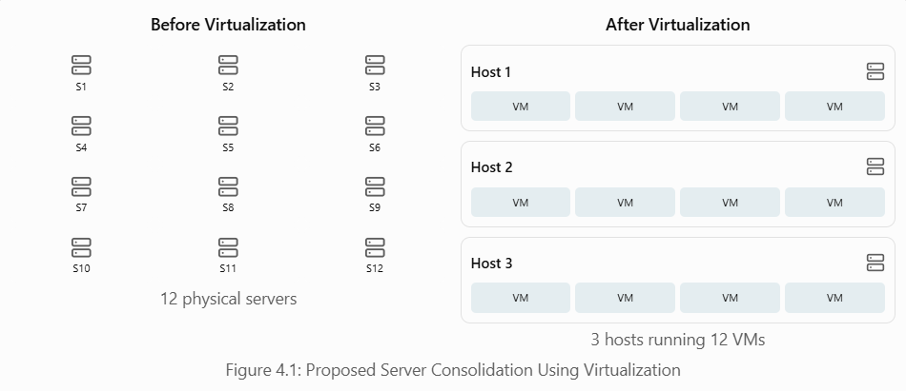Important: Three hosts are only an average-load estimate. Since the university experiences CPU peaks above 95%, actual capacity planning must also consider peak demand, RAM, storage, redundancy and host failures. Cloud auto-scaling can help manage these periods.
Benefits of Virtualization
- Live Migration: Moves running virtual machines between physical hosts with minimal interruption.
- Snapshots: Capture the state of a virtual machine for recovery or testing.
- Resource Over-Commitment: Allows virtual resources to be allocated beyond physical capacity when workloads do not fully use them simultaneously.
- Cost Reduction: Reduces the number of physical servers and associated power and maintenance costs.
Risks and Limitations
- Noisy Neighbour: One VM may consume excessive resources and affect other VMs.
- Hypervisor Failure: Failure of a physical host can interrupt multiple virtual machines.
- Security Isolation: Weak VM isolation or configuration can expose sensitive information.
- Resource Overloading: Excessive resource allocation can cause slow performance.
Conclusion
Server virtualization allows the university to consolidate underutilized physical servers, reduce infrastructure costs and simplify management. Using Type 1 hypervisors, virtual machines and containers provides a flexible solution for university applications. Peak-load testing and redundancy are necessary before final deployment.

TASK 5-Apply Web Services
Answer

Introduction
Web services allow different software applications to communicate and exchange data over the internet. They help connect university systems such as the Student Information System, Exam Portal, Library System and Fee Payment System.
In cloud computing, web services support Service-Oriented Architecture (SOA) by allowing applications to share reusable services.
SOAP, WSDL, UDDI and RESTful Services
Technology | Description
SOAP | A messaging protocol that uses XML to exchange structured information between applications.
WSDL | Web Services Description Language describes the operations and interfaces of a web service.
UDDI | Universal Description, Discovery and Integration helps publish and discover web services.
REST | An architectural style that uses HTTP methods and commonly exchanges data in JSON format.
SOAP vs REST:
- SOAP provides standardized messaging and supports enterprise security specifications.
- REST is lightweight, flexible and commonly used for web and mobile applications.
- REST uses HTTP methods such as GET, POST, PUT and DELETE.
- SOAP generally uses XML, while REST can use JSON or XML.
Proposed University Web Services
The university can expose three important functions as web services.
Web Service | API Endpoint | HTTP Method
Student Result Lookup | /api/results/101 | GET
Student Fee Payment | /api/payments | POST
Library Book Search | /api/library?title=cloud | GET

Sample API Requests and Responses
API 1 – Student Result Lookup
Purpose: Allows authenticated students to check examination results online.
Request:

Sample JSON Response:
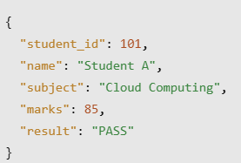
Recommended Technology: REST, because it provides fast and lightweight data exchange for web and mobile applications.
API 2 – Student Fee Payment
Purpose: Allows students to pay university fees through an authorized payment service.
Request:
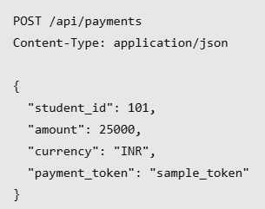
Sample JSON Response:
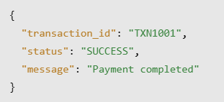
Recommended Technology: REST over HTTPS with authentication, payment-provider verification and transaction protection. SOAP may be chosen if an existing banking integration requires it.
API 3 – Library Book Search
Purpose: Allows students to search for available books in the university library.
Request:

Sample JSON Response:
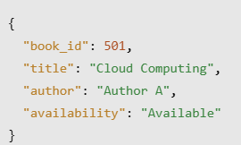
Recommended Technology: REST, because it supports simple and efficient searching.
Web Services Architecture
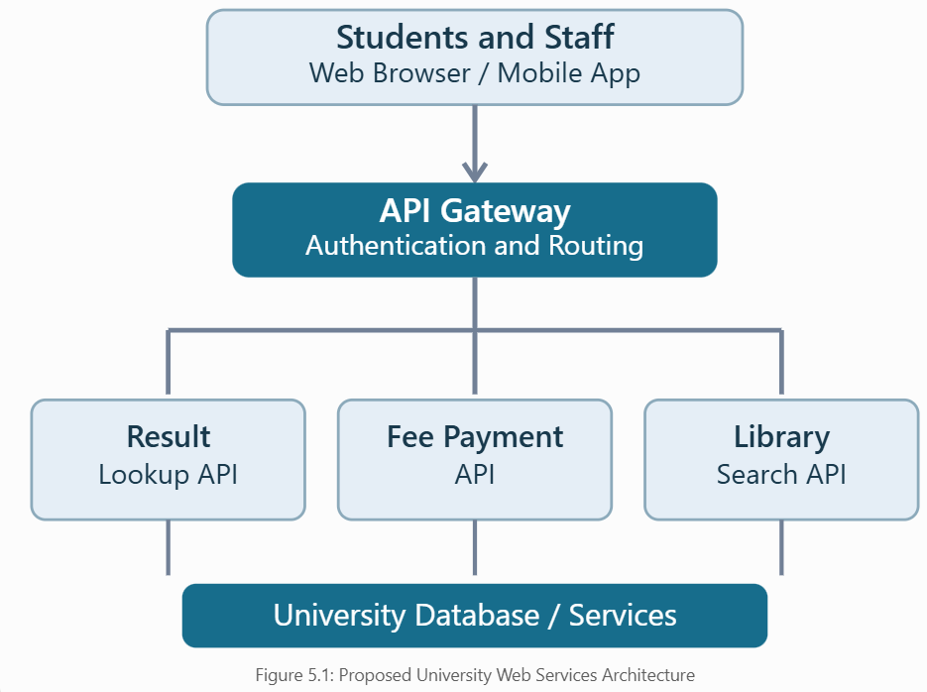
Benefits of Web Services to the University
- Enables communication between different university applications.
- Allows students to access results, payments and library services online.
- Supports future mobile application development.
- Reduces duplication by reusing existing services.
- Improves flexibility and integration with affiliated colleges.
Conclusion
Web services help the university integrate different applications through standardized communication. RESTful APIs are suitable for most student-facing services because they are lightweight and scalable. Secure authentication and HTTPS help protect sensitive university information.

TASK-6: Analyse the Service Models: IaaS, PaaS and SaaS Answer

Introduction
Cloud computing provides three main service models: Infrastructure as a Service (IaaS), Platform as a Service (PaaS), and Software as a Service (SaaS).
These models help the university reduce infrastructure costs, improve scalability and simplify the management of applications such as the Student Information System, Learning Management System, Library System, Exam Portal and Email.
Cloud Service Models
Infrastructure as a Service (IaaS)
IaaS provides virtual servers, storage and networking over the internet. The university manages the operating system and applications, while the cloud provider manages physical infrastructure.
Example: Amazon EC2 (AWS).
Platform as a Service (PaaS)
PaaS provides a platform for developing, deploying and managing applications without maintaining the underlying servers and operating systems.
Example: Google App Engine.
Software as a Service (SaaS)
SaaS provides ready-to-use software applications accessed through the internet. The cloud provider manages the application and infrastructure.
Example: Microsoft 365.
Responsibility Layers
Component | IaaS | PaaS | SaaS
Applications | University | University | Provider
Data | University | University | Shared responsibility
Runtime | University | Provider | Provider
Operating System | University | Provider | Provider
Virtualization | Provider | Provider | Provider
Physical Servers | Provider | Provider | Provider
Storage and Networking Infrastructure | Provider | Provider | Provider
Note: Even in SaaS, the university remains responsible for its data governance, user access and correct configuration.
Mapping University Applications to Cloud Service Models
University Application | Service Model | Reason
Student Information System (SIS) | IaaS | Supports migration of the existing legacy application with greater control over configuration.
Learning Management System (LMS) | SaaS | Provides ready-to-use learning features and reduces maintenance.
Library System | PaaS | Supports development of a customizable online library application.
Exam Portal | PaaS | Supports application deployment and auto-scaling during examinations.
University Email | SaaS | Provides managed email services without maintaining email servers.
Justification:
The Student Information System uses IaaS because the university may need to retain its existing software and operating system.
The LMS and Email systems use SaaS because they can use ready-made applications with less maintenance.
The Library System and Exam Portal use PaaS because they need customizable features and flexible scaling.
Comparison of IaaS, PaaS and SaaS
Feature | IaaS | PaaS | SaaS
Control | High | Medium | Low
Cost | Usage-based infrastructure cost | Usage-based platform cost | Subscription-based
Scalability | Configured by university | Often built-in or automated | Managed by provider
Maintenance | High | Medium | Low
Vendor Lock-in | Moderate | Moderate to High | Often High
Example | AWS EC2 | Google App Engine | Microsoft 365
Benefits to the University
- Cost Reduction: Reduces the need to purchase and maintain physical servers.
- Scalability: PaaS applications can scale during admission and examination periods.
- Easy Maintenance: SaaS providers handle application updates and infrastructure maintenance.
- Flexibility: IaaS allows the university to run legacy applications with custom configurations.
- Accessibility: Students and staff can access cloud services from different campuses.
Recommended Cloud Service Model
A combination of IaaS, PaaS and SaaS is recommended for the university.
- IaaS is suitable for legacy university applications.
- PaaS is suitable for developing and scaling web applications.
- SaaS is suitable for email and learning management services.
This approach balances cost, scalability, control and maintenance requirements.
Conclusion
IaaS, PaaS and SaaS provide different levels of control and management. By combining these cloud service models, the university can modernize its existing applications, reduce infrastructure costs and improve digital services for students and staff.

TASK-7 Examine XaaS: Answer

Introduction
XaaS (Anything as a Service) is a cloud computing model that provides various IT resources and services through the internet on a subscription or pay-per-use basis.
XaaS helps the university reduce infrastructure costs, improve scalability and simplify the management of computing services.
Types of XaaS
XaaS Model | Description
DaaS (Desktop as a Service) | Provides virtual desktops accessible through the internet.
BaaS (Backend as a Service) | Provides backend services such as authentication, databases and notifications.
FaaS (Function as a Service) | Executes small functions without managing servers.
DBaaS (Database as a Service) | Provides cloud-hosted databases with managed maintenance and backups.
SECaaS (Security as a Service) | Provides cloud-based security services such as threat detection and access protection.
DRaaS (Disaster Recovery as a Service) | Helps restore applications and data after system failures or disasters.
Recommended XaaS Services for the University
Database as a Service (DBaaS)
- Stores student records, examination results and library information.
- Reduces the need for manual database maintenance.
- Supports automated backups and database scaling.
- Improves data availability and management.
Disaster Recovery as a Service (DRaaS)
- Protects university applications from unexpected system failures.
- Helps restore important applications and data.
- Reduces downtime during admissions and examinations.
- Provides a recovery solution without maintaining a separate physical disaster recovery centre.

Risks of Using Multiple XaaS Providers
- Vendor Lock-in: Migrating services from one provider to another may be difficult.
- Data Security: Sensitive university information must be protected across different services.
- Service Dependency: Failure of one provider may affect connected applications.
- Cost Management: Using multiple subscription services may increase operational costs.
- Integration Complexity: Connecting services from different providers may require additional configuration.
Benefits to the University
- Reduces the cost of purchasing physical infrastructure.
- Improves scalability and resource management.
- Provides reliable backup and disaster recovery options.
- Reduces maintenance work for university IT staff.
- Supports modern digital services across all four campuses.
Conclusion
XaaS provides flexible and cost-effective cloud services for the university. DBaaS and DRaaS are the most suitable additional services because they improve database management, backup, disaster recovery and application availability while reducing infrastructure maintenance.

TASK-8 Design the Cloud Solution Architecture: Answer

Introduction
Cloud solution architecture defines how cloud resources, applications, databases and security services are connected to provide reliable computing services.
The proposed university cloud architecture combines virtualization, web services, IaaS, PaaS, SaaS and XaaS to improve scalability, availability and cost efficiency across four campuses.

Proposed Cloud Architecture Diagram
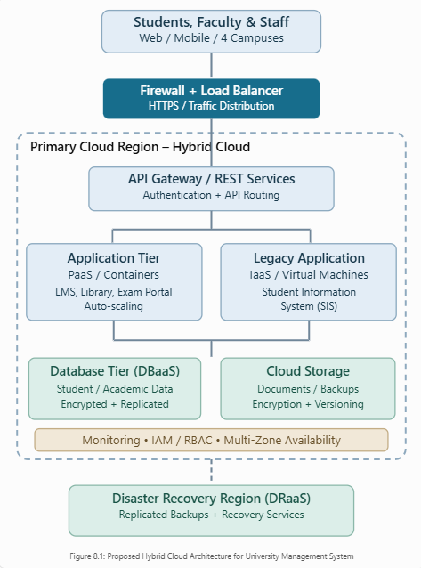

Deployment and Service Models
Recommended Deployment Model: Hybrid Cloud
A hybrid cloud combines controlled private infrastructure for sensitive student information with public cloud services for scalable applications.
Component | Service Model | Purpose
Student Information System | IaaS | Runs legacy applications using virtual machines.
Library and Exam Portal | PaaS | Provides scalable web applications.
LMS and Email | SaaS | Provides managed learning and communication services.
University Database | DBaaS | Stores academic records with managed backups.
Disaster Recovery | DRaaS | Provides recovery of data and applications.
API Gateway | Managed Cloud Service | Secures and manages API requests.
Working of the Proposed Architecture
- Students and staff access university services through web browsers or mobile applications.
- The firewall and load balancer protect the system and distribute incoming requests.
- The API gateway authenticates and routes requests to the appropriate applications.
- Virtual machines host legacy systems, while PaaS applications and containers provide modern university services.
- Managed databases and cloud storage store student records, results and academic documents.
- Disaster recovery services protect important data and support recovery during failures.
Auto-Scaling and Elasticity
During admissions and examinations, the university experiences high traffic.
- Auto-scaling automatically increases application instances when demand increases.
- Load balancers distribute traffic across available application instances.
- When traffic decreases, unnecessary instances are removed to reduce cost.
- Database capacity and connections are monitored to avoid bottlenecks.
Security and Availability Measures
Measure | Purpose
Identity and Access Management (IAM) | Restricts access based on user roles.
Encryption | Protects student records during storage and transmission.
Firewall and API Gateway | Protects applications from unauthorized requests.
Multi-Zone Deployment | Reduces downtime during infrastructure failures.
Automated Backups | Prevents permanent data loss.
Disaster Recovery | Helps restore services after major failures.
Benefits of the Proposed Architecture
- Reduces dependence on outdated physical servers.
- Improves scalability during examination and admission periods.
- Supports secure access from all four campuses.
- Simplifies application management through cloud services.
- Improves availability through redundancy, backups and disaster recovery.
Conclusion
The proposed hybrid cloud architecture provides a secure, scalable and cost-effective solution for the university. By integrating IaaS, PaaS, SaaS, virtualization and web services, the university can modernize its existing systems while improving performance, availability and resource management.

TASK-9: Hands-on Implementation and Documentation Answer
Aim
To develop and test a simple cloud-ready Student Result Management System using Flask, SQLite, REST APIs and Docker containerization, and demonstrate retrieval of examination results through a web interface.
Tools and Technologies Used
Python 3.13, Flask, SQLite, HTML, CSS, JavaScript, REST API, Docker Desktop, WSL 2, Gunicorn, PowerShell and a web browser. Render PaaS is configured as the intended cloud deployment platform; live deployment evidence has not yet been provided.
Procedure
  - Developed the Flask application and created a SQLite database containing three sample student records.
  - Implemented REST API endpoints for health checking, student listings and individual examination results.
  - Designed a responsive student portal with ID search, marks, PASS/FAIL status and input validation.
  - Created a Docker image using the project Dockerfile and installed the required Python dependencies.
  - Started the container with host port 5052 mapped to application port 5000.
  - Verified successful and invalid API requests using curl and inspected Docker logs.
  - Restarted the container and checked that the health endpoint and student-result endpoint remained operational.
  - Collected screenshots of the actual execution as evidence.
Sample Test Data
Student ID | Name | Marks / 100 | Result
101 | Student A | 85 | PASS
102 | Student B | 72 | PASS
103 | Student C | 38 | FAIL
Observed API Responses
GET /api/results/101 returned HTTP 200 with Student A, Cloud Computing, 85 marks and PASS. GET /api/results/999 returned HTTP 404 with the message “Student not found”. GET /api/health returned HTTP 200 with database status “connected”.

Output Evidence – Docker Build and Container
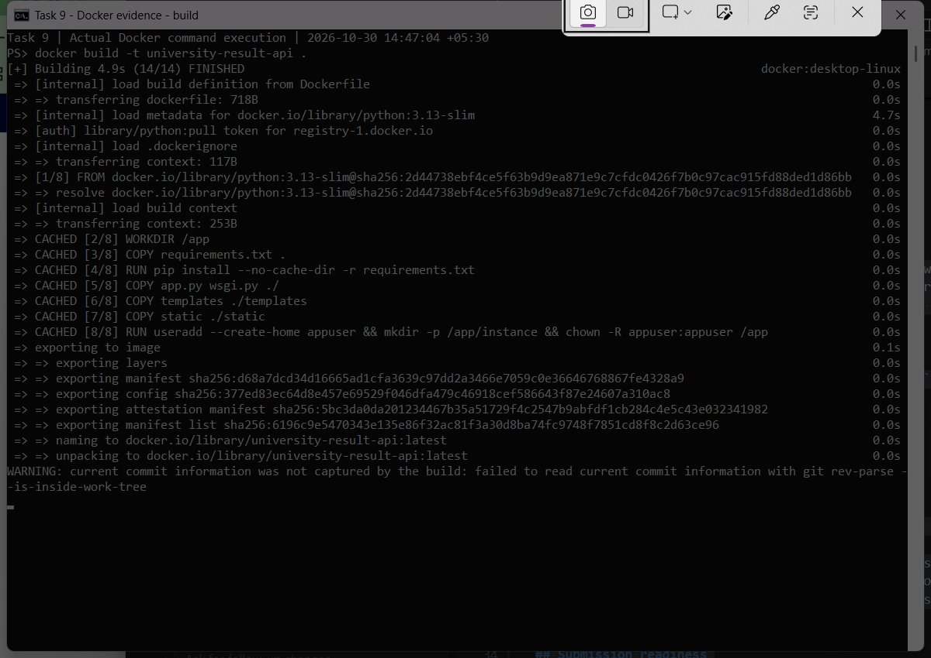
Figure 10.1. Successful Docker image build (14/14 steps completed).
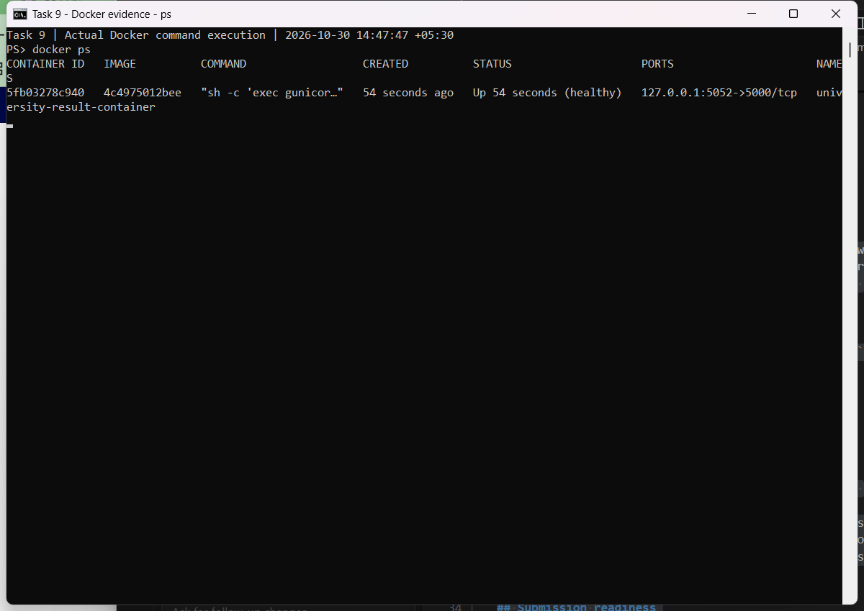
Figure10.2. Running Docker container reported as healthy on localhost:5052.

Output Evidence – Student Result and REST API
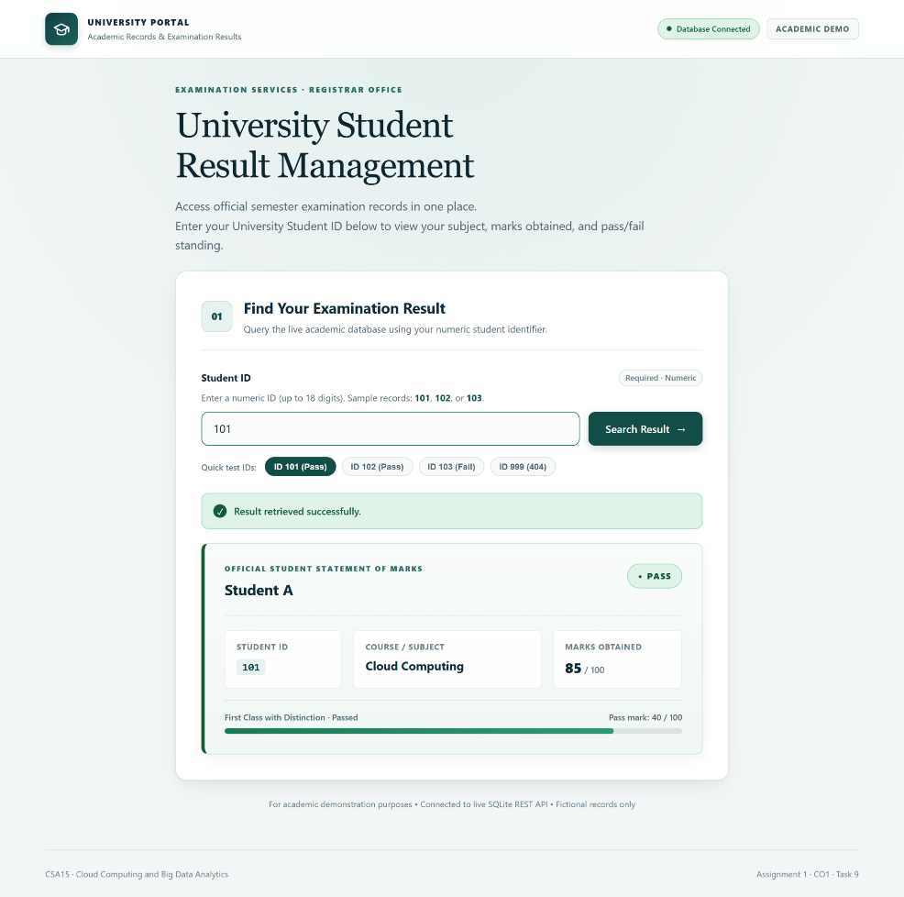
Figure 10.3. Student result portal displaying ID 101, 85/100 and PASS.
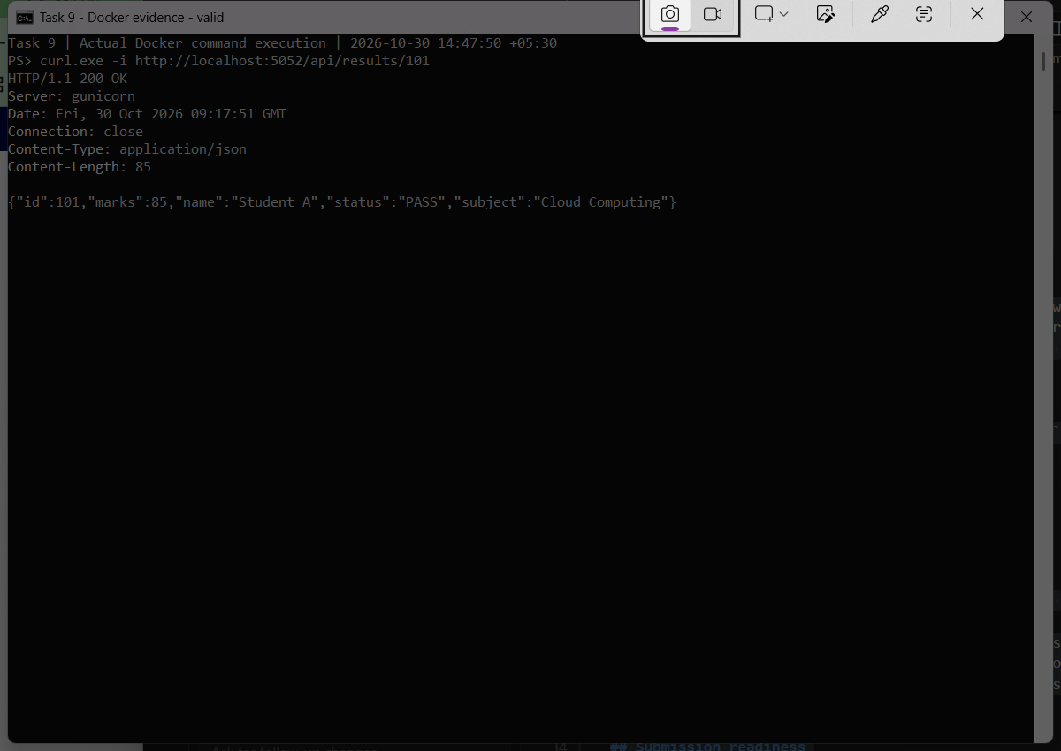
Figure 10.4. API response for student 101: HTTP 200 OK.

Output Evidence – Invalid Student and Error Handling
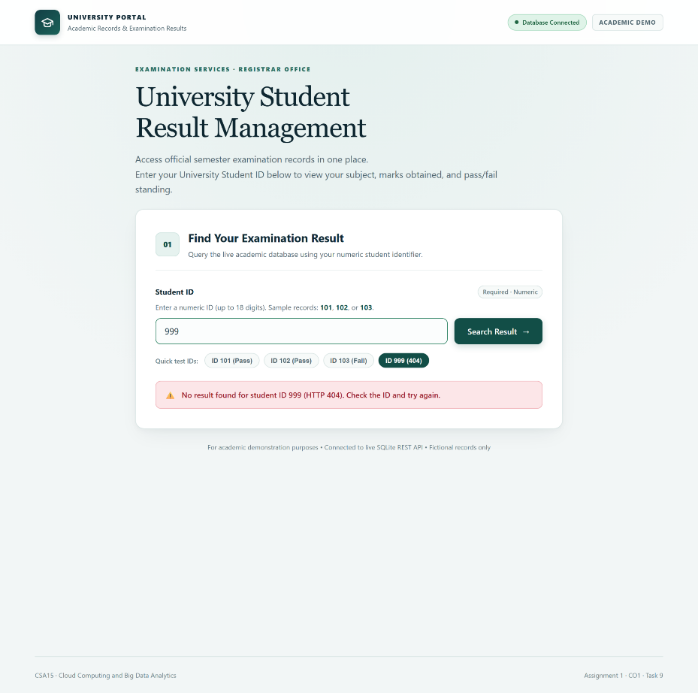
Figure 10.5. Student portal displaying an error for unknown ID 999.
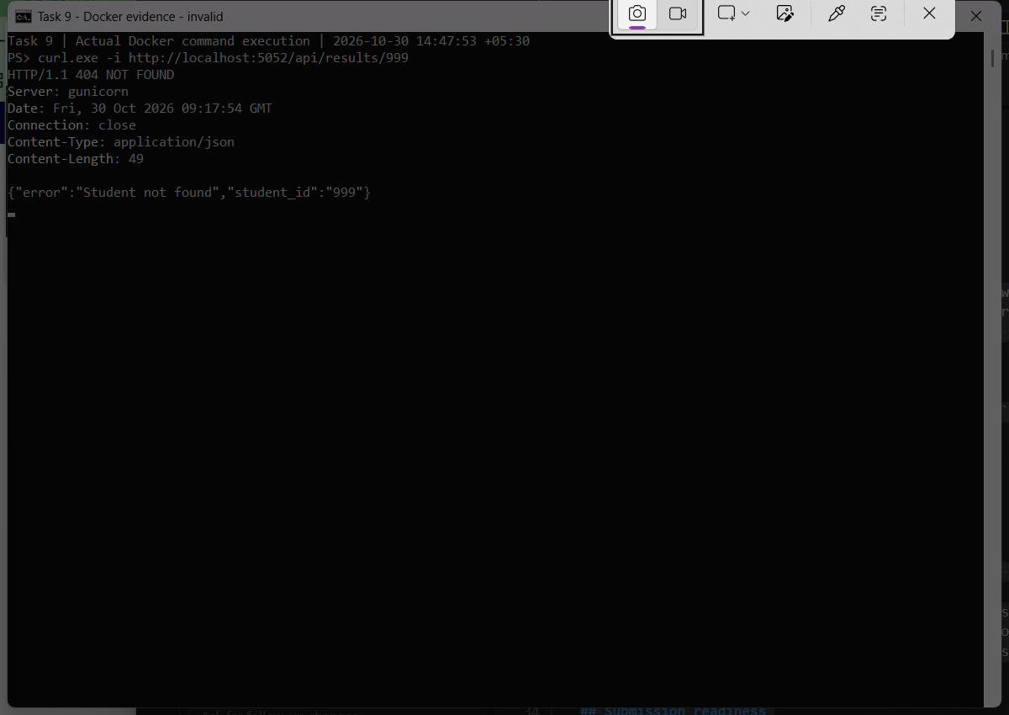
Figure 10.6. Actual API response for student 999: HTTP 404 Not Found.

Output Evidence – Container Logs and Restart
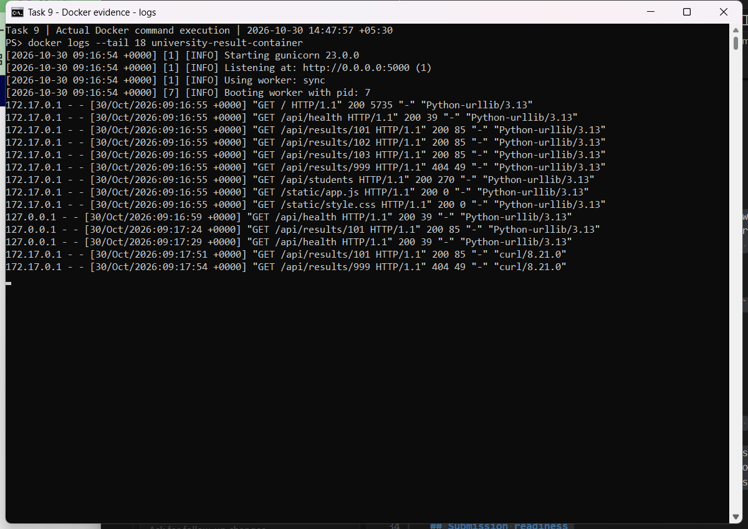
Figure 10.7. Gunicorn server logs showing successful and unsuccessful HTTP requests.
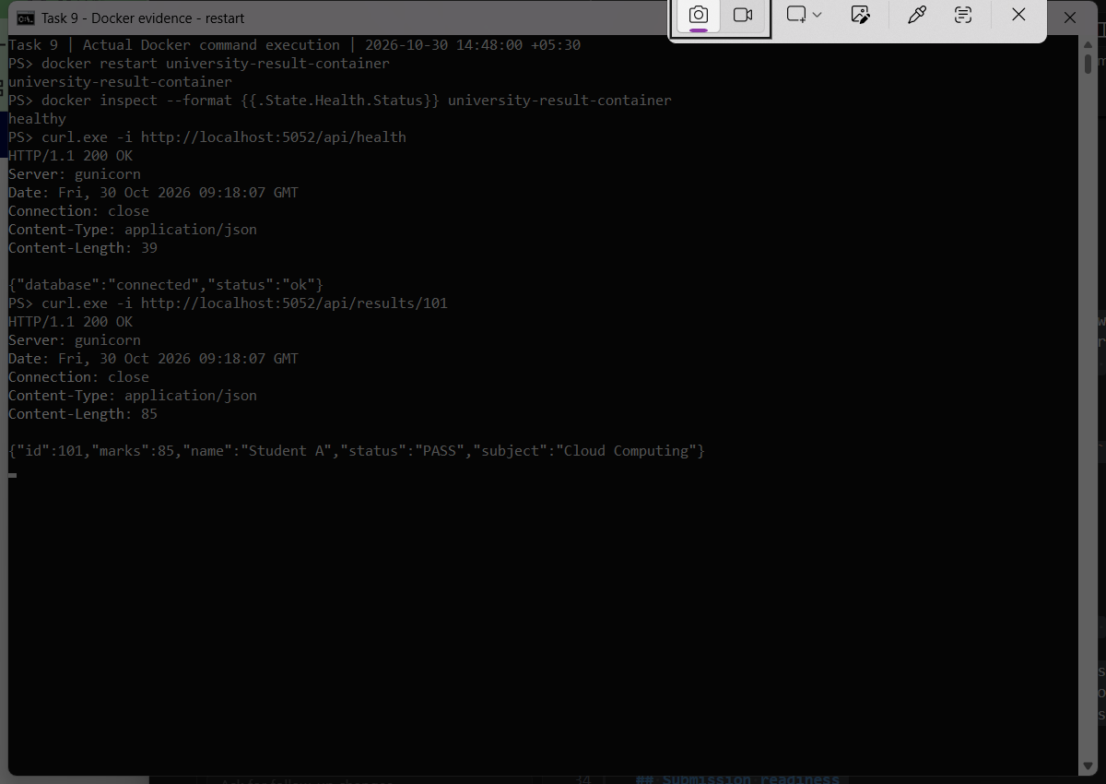
Figure 10.8. Docker restart, healthy status and successful API responses after restart.

Additional Interface Verification
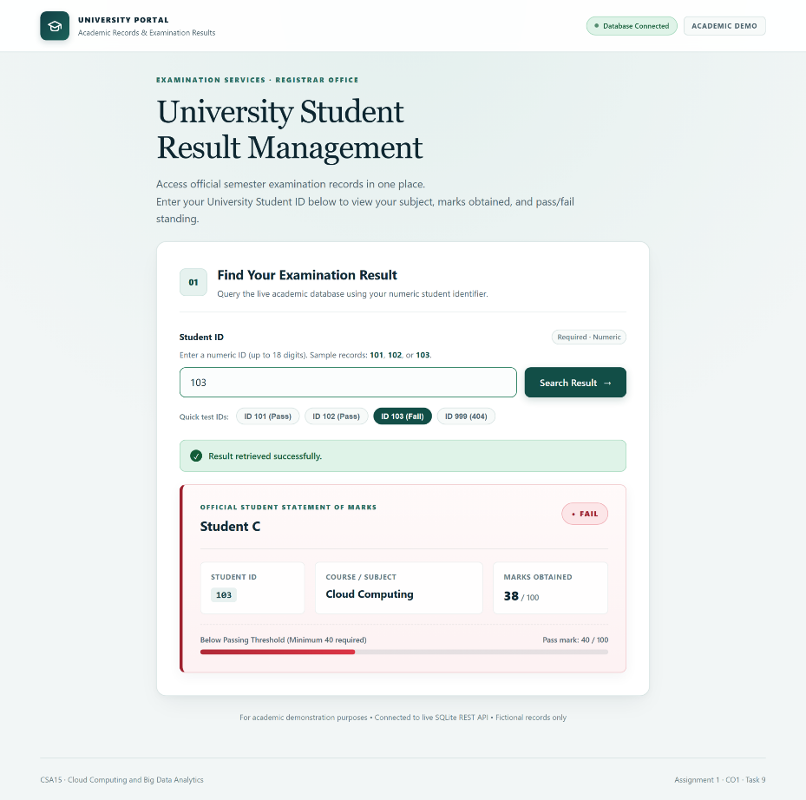
Figure 10.9. Student ID 103 with 38/100 and FAIL status.
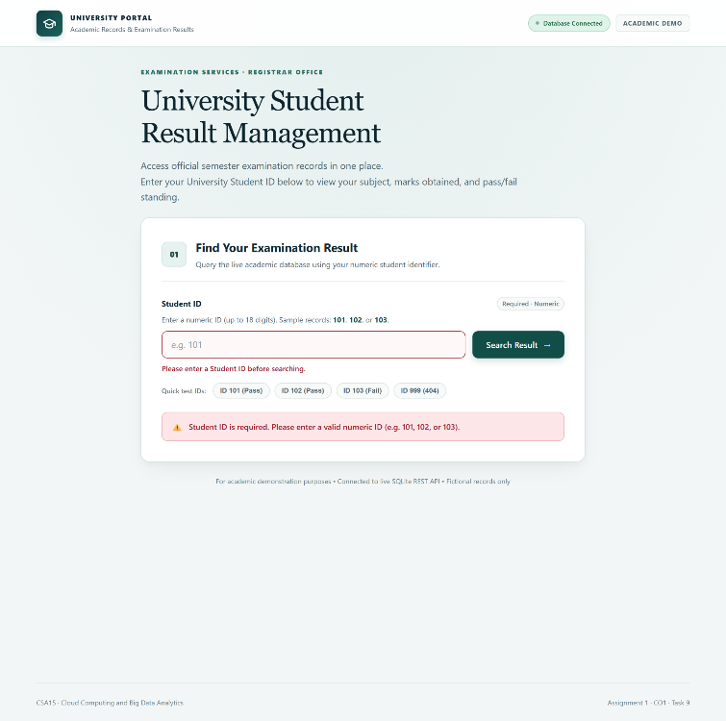
Figure 10.10. Client-side validation when the Student ID field is empty.

Responsive Design Evidence
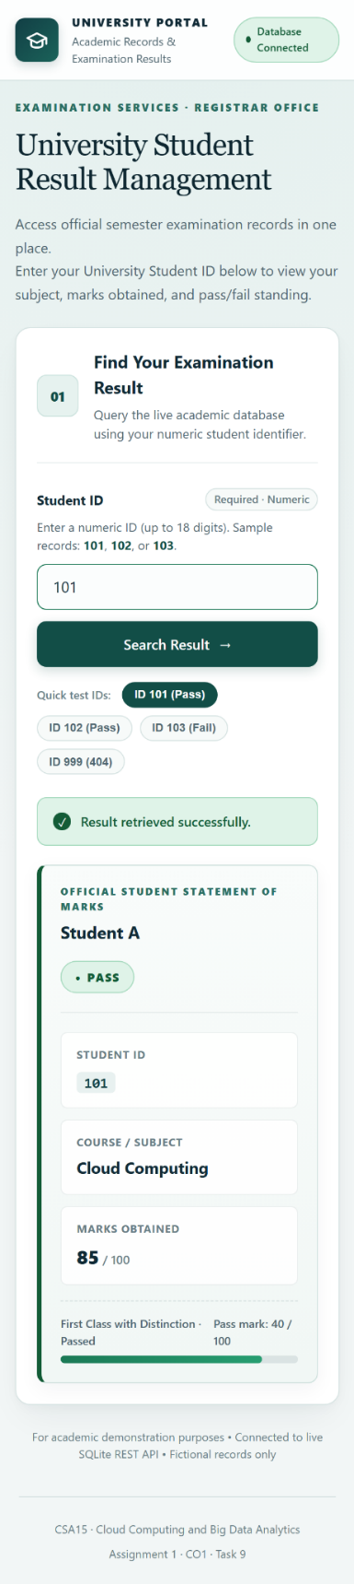
Figure 10.11. Mobile-responsive layout of the result management portal.

Testing Summary
• Docker image build: Successful; screenshot shows all 14 build steps completed.
• Docker container: Running and healthy, mapped to localhost:5052.
• Student 101 API: HTTP 200; marks 85; PASS.
• Student 999 API: HTTP 404; student not found.
• Container restart: Successful; health check and student result requests returned HTTP 200 afterward.
• Local automated tests: 15 passed according to the development verification report.
• Render PaaS deployment: Pending; no verified public URL or Render screenshot supplied.
Result
The Student Result Management System was successfully developed and tested locally. Docker image creation, container execution, REST API responses, error handling and container restart were demonstrated using actual screenshots. The system correctly retrieves sample student results and reports an HTTP 404 error for unknown student IDs.
Conclusion
This experiment demonstrates the use of a containerized web application for a cloud-computing assignment. Flask provides the REST API, SQLite stores sample examination records, and Docker packages the application into a portable runtime environment. The next step is to deploy the reviewed application to Render and verify it using a public URL. Until that step is completed, the evidence establishes successful local containerization rather than live cloud hosting.

TASK 10 – Cost Analysis, Risk Assessment and Migration Roadmap

Cost Comparison of Cloud Deployment Models
The university currently operates 12 physical servers to support 25,000 students and 2,000 staff across four campuses. Migrating to cloud computing can reduce infrastructure costs, improve scalability and simplify maintenance.
The following table compares the existing on-premises system with IaaS and a hybrid PaaS/SaaS cloud solution.
Parameters | On-Premises | IaaS Cloud | Hybrid PaaS/SaaS
Capital Cost (CapEx) | High | Low | Low
Operating Cost (OpEx) | High | Medium | Medium
Scalability | Limited | High | Very High
Availability | Depends on local servers | High | High
Security | Managed by university | Shared responsibility | Shared responsibility
Maintenance | High | Medium | Low
Implementation Effort | High | Medium | Medium
Disaster Recovery | Expensive | Cloud backup | Managed backup and recovery
Observation: A hybrid cloud solution combining IaaS, PaaS and SaaS provides a good balance of cost, scalability, security and maintenance.
Three-Year Cost Estimation
The following values are illustrative estimates for academic comparison, not actual cloud-provider quotations.
Assumptions:
- The university operates 12 physical servers.
- The calculation covers three years.
- Cloud services follow a pay-as-you-use pricing model.
- Costs include infrastructure, maintenance, security and technical support.
- Migration is treated as a one-time expense.
Cost Component | On-Premises | IaaS Cloud | Hybrid PaaS/SaaS
Initial infrastructure / migration | ₹24 lakh | ₹5 lakh | ₹6 lakh
Annual operating cost | ₹15 lakh | ₹18 lakh | ₹15 lakh
Three-year operating cost | ₹45 lakh | ₹54 lakh | ₹45 lakh
Total three-year cost | ₹69 lakh | ₹59 lakh | ₹51 lakh
Calculations:
On-Premises Cost = ₹24 lakh + (₹15 lakh × 3) = ₹69 lakh
IaaS Cost = ₹5 lakh + (₹18 lakh × 3) = ₹59 lakh
Hybrid PaaS/SaaS Cost = ₹6 lakh + (₹15 lakh × 3) = ₹51 lakh
Estimated Savings:
Savings = ₹69 lakh − ₹51 lakh = ₹18 lakh
Percentage Savings = (18 / 69) × 100 = 26.09%
Therefore, the proposed hybrid cloud model could reduce the estimated three-year cost by approximately 26% compared with the existing on-premises system, under the stated assumptions.
Risk Analysis and Mitigation
Risk | Impact | Mitigation Strategy
Vendor Lock-in | Difficult to change cloud providers | Use standard APIs, Docker and portable applications
Data Privacy | Student information may be exposed | Encryption, access control and secure authentication
Cloud Downtime | University services become unavailable | Multi-zone deployment, monitoring and disaster recovery
Skills Gap | Staff may struggle with cloud technologies | Provide training and technical workshops
Unexpected Costs | Increased cloud usage raises expenses | Set budgets, alerts and resource limits

Recommended Cloud Migration Strategy
A hybrid cloud architecture is recommended because it allows the university to retain sensitive systems under stronger institutional control while moving suitable applications to scalable cloud services.
The proposed service allocation is:
- Student Information System (SIS): IaaS, providing greater control over sensitive student records.
- Learning Management System (LMS): SaaS, reducing software maintenance.
- Library Management System: PaaS, supporting application development and integration.
- Examination Portal: PaaS, supporting scaling during examination periods.
- University Email: SaaS, reducing server administration.
Phased Cloud Migration Roadmap
Phase 1 – Assessment and Planning
Identify existing applications, analyze server utilization, classify sensitive data and estimate migration costs.
Phase 2 – Email and LMS Migration
Move email and LMS to SaaS first because these are relatively straightforward services to migrate and maintain.
Phase 3 – Library and Examination Portal
Migrate these applications to PaaS with database management, automated scaling and backup facilities.
Phase 4 – Student Information System
Migrate SIS carefully using IaaS, encryption, role-based access control and thorough data verification.
Phase 5 –Testing and Optimization
Conduct performance, security and availability testing. Monitor usage, optimize costs and establish disaster recovery procedures.
Final Recommendation
The university should adopt a hybrid cloud solution using IaaS, PaaS and SaaS based on application requirements. This approach reduces dependence on physical servers, supports future growth, improves service availability and simplifies maintenance.
The estimated three-year cost is ₹51 lakh compared with ₹69 lakh for the existing on-premises infrastructure. A phased migration minimizes disruption and allows the university to maintain data security while improving overall system performance.
Conclusion: The proposed hybrid cloud model is a cost-effective, scalable and flexible solution for modernizing the university's IT infrastructure.

TASK 11 – Day-4 Design Challenge: Cloud Architecture Modification

Impact Analysis of New Requirements
The university introduces new requirements, including a mobile application, API integration with 40 affiliated colleges, 10× peak traffic, 99.9% availability and a limited operating budget.
Requirement | Impact on Cloud System
Mobile Application | Requires secure REST APIs for student and staff access
40 Affiliated Colleges | Requires API Gateway and college-specific authentication
10× Peak Traffic | Requires auto-scaling and load balancing
99.9% Availability | Requires multi-zone deployment and automatic failover
Limited Budget | Requires pay-as-you-use resources and cost monitoring
These changes increase the demand for computing resources, database performance, network security and reliable service delivery.
2. Evaluation of Original Cloud Design
The original design uses a hybrid cloud architecture combining IaaS, PaaS and SaaS.
Strengths:
- Reduces physical server maintenance.
- Provides flexible cloud infrastructure.
- Supports application scalability.
- Improves data backup and recovery.
Limitations:
- No dedicated API Gateway for affiliated colleges.
- Insufficient planning for 10× peak traffic.
- No explicit multi-zone availability design.
- Additional security and cost controls are required.
Decision: MODIFY the existing hybrid cloud architecture.
The original design is suitable for the university, but it needs additional components to support new requirements. Modifying the architecture is more practical and cost-effective than completely redesigning it.
Proposed Modified Cloud Architecture
The modified architecture includes the following components:
- API Gateway: Provides secure access to mobile applications and affiliated colleges using authentication and rate limiting.
- Load Balancer: Distributes incoming traffic across multiple application instances.
- Auto-Scaling: Automatically increases or decreases computing resources according to demand.
- Managed Database: Provides secure storage, backups and recovery.
- Multi-Zone Deployment: Improves availability by running services across multiple availability zones.
- Monitoring and Security: Uses encryption, role-based access control, tenant isolation and budget alerts.
Architecture Diagram
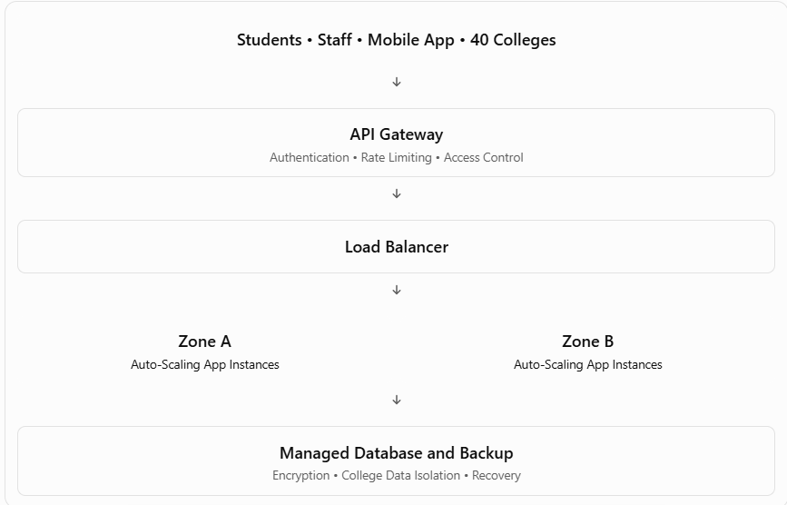
Evidence-Based Justification
A. Capacity Calculation
Assume the original peak traffic is 500 requests per minute.
New Peak Traffic = 500 × 10 = 5,000 requests/minute
Assume one application instance supports 1,000 requests per minute.
Required Instances = 5,000 / 1,000 = 5 instances
An additional instance can provide spare capacity, giving a planning target of six instances. Actual capacity must be confirmed through load testing.
B. Availability Calculation
Required Availability = 99.9%
Annual Hours = 365 × 24 = 8,760 hours
Maximum Downtime = 8,760 × 0.001 = 8.76 hours/year
Multi-zone deployment, load balancing and automatic failover help meet this availability target.
C. Cost Justification
Using the assumed costs from Task 10:
Deployment | Estimated Three-Year Cost
Original On-Premises | ₹69 lakh
Original Hybrid Cloud | ₹51 lakh
Modified Hybrid Cloud | ₹63.6 lakh
The modified cloud estimate assumes an additional ₹35,000 per month for API management, extra computing capacity, high availability and monitoring.
Additional Cost = ₹35,000 × 36 = ₹12.6 lakh
Modified Hybrid Cost = ₹51 lakh + ₹12.6 lakh = ₹63.6 lakh
The modified architecture remains ₹5.4 lakh below the original on-premises estimate, although the on-premises estimate does not include upgrades needed for the new requirements.
D. Security and Trade-Offs
Each affiliated college receives a separate tenant identity and role-based permissions. Encryption, HTTPS and audit logging protect student records and prevent unauthorized cross-college access.
The modified architecture increases cloud operating costs and management complexity. However, it offers better scalability, security and availability. Auto-scaling and budget alerts help control expenses.
Conclusion
The university should MODIFY its existing hybrid cloud architecture rather than retain it unchanged or redesign it completely. The addition of an API Gateway, load balancer, auto-scaling, managed database and multi-zone deployment supports mobile access, 40 affiliated colleges, 10× peak traffic and the 99.9% availability target.
This approach provides a scalable, secure and cost-conscious cloud solution while preserving the benefits of the original design.

